Royal Enfield Documentation
Workflow Management System
The Workflow Management System encompasses the following key modules:
1. RE Dealer Onboarding / Offboarding
2. Field Visit Report & Action Plan
3. Dealer Claim Management
4. Approval Hierarchy
1A. Explanation of the Onboarding Process
The Dealer Onboarding Process is a structured, multi-stage workflow that ensures each dealer is evaluated, approved, and activated through transparent assessments, financial due diligence, and audit checkpoints. The process combines automated system-driven steps with manual reviews from various business stakeholders to maintain compliance, quality, and operational readiness.

1. Inquiry Capture
The onboarding journey begins when a potential dealer submits an inquiry through the “Become a Dealer” web form available on the Royal Enfield (RE) website. The system is integrated in real time with the RE website to capture all form submissions directly into the backend application. Each inquiry record includes applicant details such as name, contact information, preferred location, and any additional remarks provided. The submission triggers an entry in the system database, marking the first step in the onboarding pipeline.

2. Store Data & Vacancy Screening
Once the inquiry is received, the system automatically stores all the captured information in a structured database. Immediately after storage, a background process checks for dealership vacancy availability in the applicant’s preferred location. This validation ensures that the system filters out inquiries from locations where dealership capacity has already been fulfilled. This automated screening step minimizes manual intervention and ensures only relevant applications proceed for further review.

3. Acknowledgement or Rejection Communication
Based on the vacancy check results, the system triggers an automated email response. If no vacancy is available at the requested location, the system sends a polite rejection or non-opportunity email to the applicant, thanking them for their interest. However, if the location has an available slot, an acknowledgement email is sent, containing a secure, time-bound link to the dealer questionnaire form. This ensures clear, automated, and timely communication with all applicants.

4. Questionnaire Handling
Applicants with an active opportunity link are required to complete a detailed dealer questionnaire, designed to collect objective and descriptive responses across business, financial, operational, and infrastructure parameters. The web form supports multiple input types—text, numeric entries, radio buttons, and file uploads—to capture comprehensive information.
The system also manages applicant engagement via automated reminder emails: one at D+2 (2 days after acknowledgment) and another at D+5, prompting completion. If the applicant fails to submit the form within 20 days (D+20), the system automatically expires the questionnaire link and marks the application as inactive.

5. Response Processing and Weighted Ranking
Once the applicant submits the questionnaire, the system evaluates the responses using a weighted scoring algorithm. Each question carries a predefined weight and maximum score, aligned with the evaluation framework defined by the Dealer Development (DD) team. The system calculates a weighted total score and assigns a rank to each applicant relative to other submissions for the same location. This ranking forms the basis for shortlisting and subsequent human evaluations.

6. Shortlisting by DD Team
The Dealer Development (DD) team reviews the system-generated ranking list and manually shortlists the top 10 applicants for each available location. The shortlisted records are then assigned to the respective Zonal Manager (ZM-DD) for regional-level evaluation. This step introduces human judgment and contextual insights into the otherwise automated scoring process, ensuring that shortlisted candidates align with brand and market standards.

7. ZM Evaluation
The Zonal Manager (ZM-DD) reviews each shortlisted applicant’s profile in detail—covering their questionnaire responses, documents, and overall business potential. After evaluation, the ZM either approves or rejects the application.
Approved applications are automatically routed to the Regional Business Manager (RBM) for the next level of review, whereas rejected ones are marked as disqualified in the system. The system also captures the ZM’s remarks and timestamps for audit traceability.

8. RBM Evaluation
At this stage, the Regional Business Manager (RBM) conducts a more comprehensive evaluation of the approved candidates, focusing on strategic alignment, financial credibility, and market readiness. The RBM can approve or reject the application within the same interface.
Approved records are automatically forwarded to the Dealer Development Lead (DDL) for coordination of the Financial Due Diligence (FDD) process. This step introduces a crucial managerial review before involving external financial audits.

9. Financial Due Diligence (FDD)
Once the DDL assigns a candidate for FDD, the system triggers a secure email to the designated external financial audit agency. The email contains a unique, OTP-protected upload link where the agency can securely upload the L1 and L2 due diligence reports.
The OTP mechanism ensures that only authorized auditors can access and upload documents, maintaining data integrity and confidentiality. Once uploaded, the reports are linked to the dealer’s record and notified to the National Business Head (NBH) for review.

10. NBH Review and Approval
The NBH (National Business Head) performs a final strategic review of the applicant based on the cumulative evaluation—from DD shortlisting through FDD reports.
If the NBH finds discrepancies or concerns, they can reject the application, which automatically halts the onboarding process and triggers a system notification to the DD team. If approved, the system transitions the applicant to the document generation stage, preparing to issue the formal Letter of Intent (LOI) and Letter of Appointment (LOA).

11. LOI & LOA Generation
Upon NBH approval, the system automatically generates the LOI (Letter of Intent) and LOA (Letter of Appointment) using predefined document templates populated with dealer-specific data such as applicant name, location, and codes.
Both documents are stored within the system and dispatched via automated emails to the dealer and relevant internal stakeholders, including CCs to DD, RBM, and NBH. The generation and distribution process is entirely system-driven to ensure standardization and eliminate delays.

12. EOR Audit & Final NBH Approval
Following LOI and LOA issuance, the EOR (Establishment & Operational Readiness) Audit is conducted to ensure the dealer’s infrastructure, manpower, and operations meet organizational standards before activation.
The Regional DD uploads the completed EOR report into the system, after which the NBH performs a final review and approval. This step confirms that all operational readiness checks have been successfully met and validated.

13. Dealer Activation
Once the NBH grants final approval, the system updates the dealer’s status to Active. During this stage, key details such as dealer inauguration date, sales/service/gear codes, and GMA codes are recorded in the system.

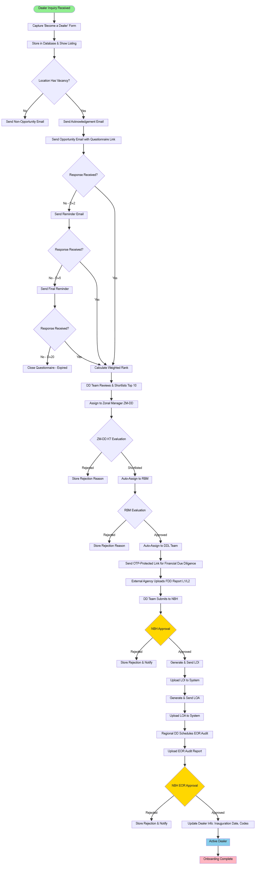
The activation triggers system notifications to all relevant departments—sales, finance, and operations—ensuring alignment across internal systems. The dealer officially becomes part of the network, completing the onboarding lifecycle.

✅ Outcome:
By the end of this process, every active dealer has undergone structured evaluation, documentation, and approval—ensuring transparency, auditability, and operational compliance from initial inquiry to final activation.
1B.Explanation of the Offboarding Process
The Dealer Offboarding Process ensures a structured, compliant, and traceable closure of a dealer’s association with the company. It formalizes the separation by capturing the resignation or termination trigger, obtaining required approvals, completing handover and financial settlements, and updating all system records.
This process balances automation (for alerts, notifications, and data handling) with manual validations (for business and legal compliance).

1. Offboarding Trigger Initiation
The offboarding process begins when a dealer’s exit is initiated, either through a dealer resignation or a company-initiated termination.
In the case of resignation, the dealer submits a formal resignation request, typically through a form or email communication. For terminations, the initiation comes from the National Business Head (NBH) or Regional Business Manager (RBM) based on business, compliance, or performance considerations.
The system captures this initiation as a new Offboarding Request Record, storing key metadata such as trigger type, dealer ID, date, and reason.

2. Record Creation & Verification
Once the trigger is logged, the system automatically creates a Dealer Offboarding Record linked to the existing dealer profile. This record contains information about the dealer’s branch, codes, and contact details.
Simultaneously, the Dealer Development (DD) team verifies the authenticity of the request to ensure that the resignation or termination has been communicated through official channels and approved by the correct authority.
This verification acts as a safeguard against accidental or unauthorized offboarding requests.

3. Notification to Stakeholders
After verification, the system sends automated email notifications to all internal stakeholders involved in the offboarding process — including the DD Team, Regional DD, Finance, Supply Chain, Legal, and Audit teams.
Each stakeholder is informed of their role in completing specific tasks (e.g., settlement, asset recovery, or compliance clearance).
This notification ensures that every department is aware of the pending offboarding and can plan accordingly to execute their responsibilities.

4. Document & Evidence Upload
The next stage involves uploading supporting documents related to the offboarding case.
Depending on the trigger type, this may include the Dealer Resignation Letter, Termination Notice, Exit Approval from NBH, and any relevant legal or compliance correspondence.
The system provides a dedicated upload interface to attach these documents under the dealer’s record. Uploaded files are version-controlled, timestamped, and auditable, ensuring transparency and accountability for each document added.

5. F&F Stakeholder Task Allocation
Once documentation is complete, the system automatically generates F&F (Full & Final) settlement tasks for each stakeholder.
Each task is assigned to a specific department or individual — for example:
- Finance: Settlement of outstanding invoices or advances.
- Supply Chain: Return or transfer of unsold stock and assets.
- Legal: Closure of contractual obligations and compliance verifications.
- Audit / IT: Account and access deactivation.
Each task includes a due date, status tracker, and remarks section. Stakeholders can mark tasks as “Completed” once finished, enabling real-time monitoring of overall progress.

6. Regional Review by DD / RBM
After all department tasks are marked complete, the Regional Dealer Development (DD) team or RBM reviews the entire F&F checklist and validates that all deliverables, settlements, and compliance items have been completed.
This regional verification acts as the first checkpoint before final business approval.
Any discrepancies or pending items are flagged back to respective departments for resolution before moving ahead.

7. NBH Approval for Exit
Once the regional review is completed, the National Business Head (NBH) performs the final business review of the offboarding case.
The NBH examines the summarized F&F report, stakeholder remarks, and supporting documents before providing formal approval.
If approved, the system transitions the dealer’s record into the “Pending Deactivation” state.
In case of rejection (e.g., incomplete documentation or unresolved financials), the record is sent back for rework, and notifications are triggered automatically to the respective departments.

8. LOI/LOA Revocation & Termination Documentation
Following NBH approval, the system automatically revokes the active LOI (Letter of Intent) and LOA (Letter of Appointment) associated with the dealer.
It then generates a Termination Letter (for company-initiated cases) or Acceptance of Resignation Letter (for voluntary exits) using pre-approved templates.
These documents are digitally signed and stored in the system, ensuring that official communication is tracked and preserved in the dealer’s digital record.

9. Dealer Code Deactivation
Once termination documentation is complete, the system marks all the dealer’s active codes — Sales, Service, GMA, and Gear — as inactive.
This ensures that the dealer no longer has access to internal systems such as billing, warranty, or dealer portals.
Simultaneously, integration hooks update connected enterprise systems (like SAP or CRM) to deactivate the dealer from any live transaction pipelines.
This automated deactivation prevents any post-exit activity and maintains system integrity.

10. Final Communication to Dealer
After the codes are deactivated, the system sends a final confirmation email to the dealer confirming that the offboarding process has been successfully completed.
The email includes a summary of the closure date, approval reference number, and a note of appreciation (for voluntary exits) or formal closure language (for terminations).
All communications are archived under the dealer’s record for future audit or reference.

11. Archive and Audit Logging
Once the dealer is fully offboarded, the system archives the dealer’s historical records into a read-only state, preserving all related documents, evaluations, correspondence, and F&F logs.
An audit log entry is created capturing every action taken throughout the offboarding process — including user IDs, timestamps, IP addresses, and event types.
This ensures complete traceability and compliance with audit and legal requirements.

12. Reporting & Analytics
Finally, the system updates the Dealer Lifecycle Dashboard to reflect offboarding analytics.
Metrics such as monthly offboarding count, average closure time, reason-wise distribution (resignation vs termination), and region-wise summaries are displayed.
These reports enable management to monitor trends, identify improvement areas, and maintain a clear overview of dealer churn and network health.
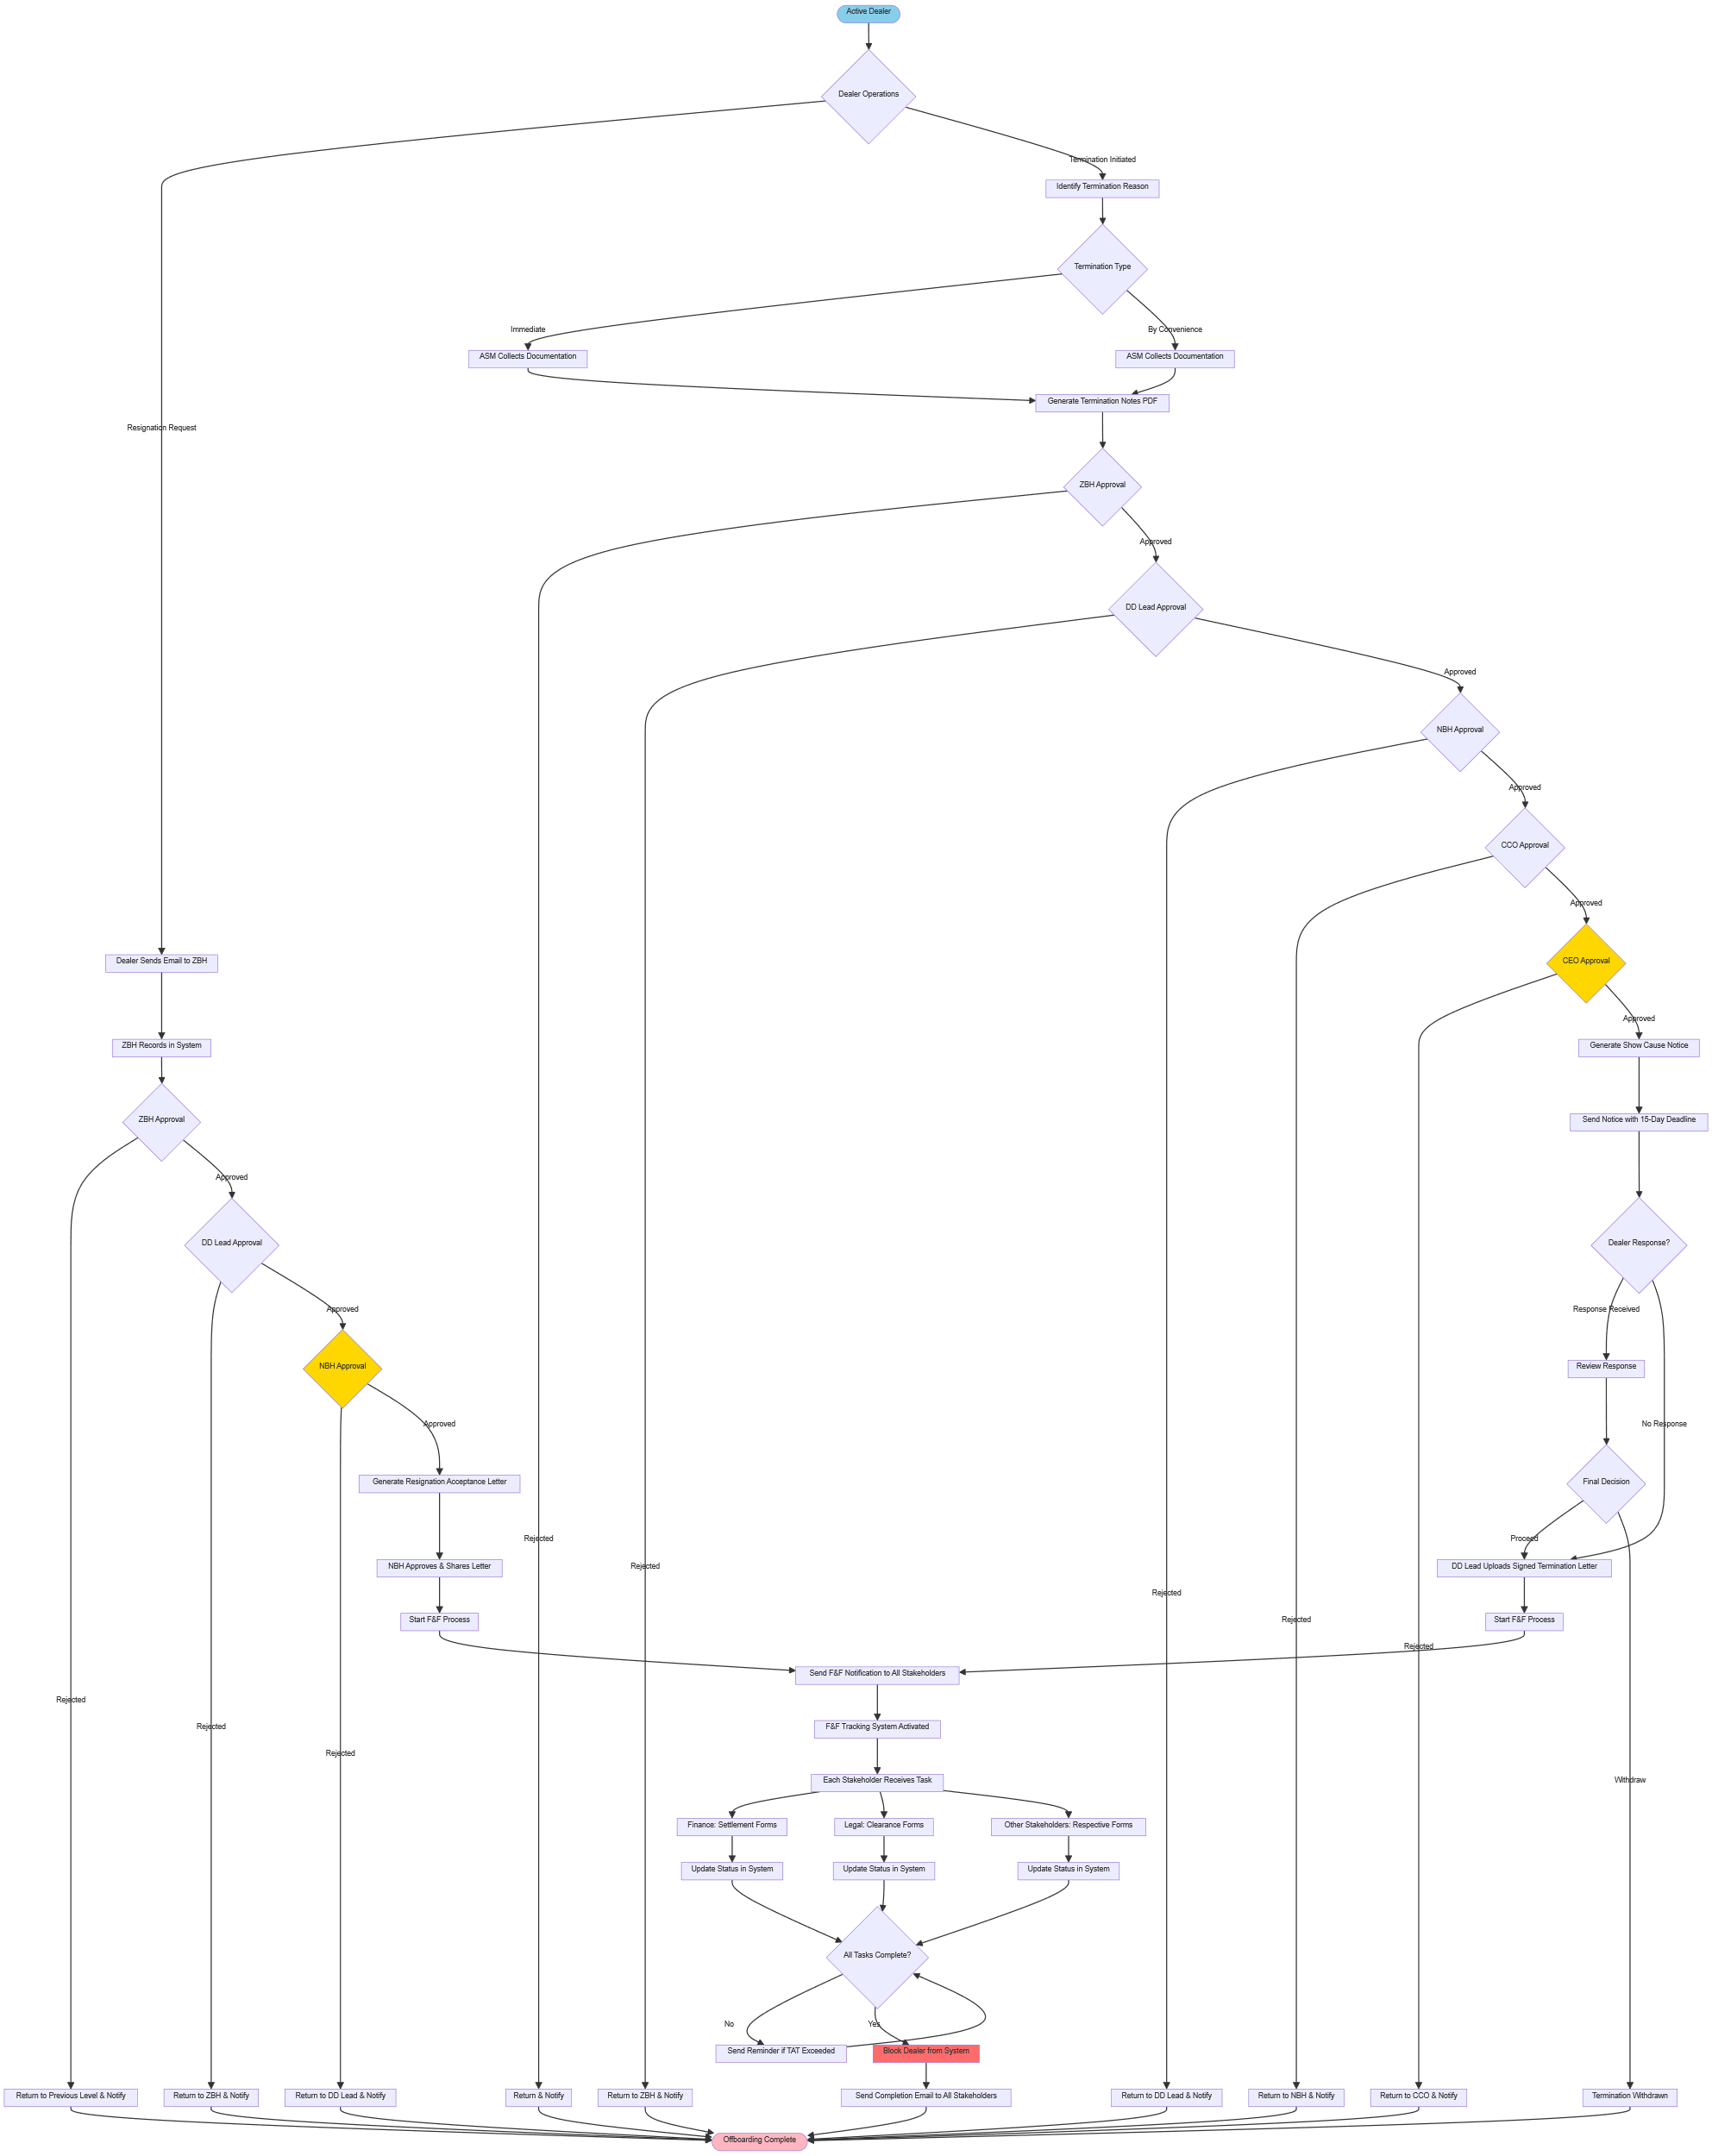
✅ Outcome:
By the end of the offboarding process, every dealer’s exit — whether voluntary or company-initiated — is systematically documented, approved, and settled across all departments.
This ensures compliance, financial closure, operational security, and data integrity, maintaining a clean and auditable dealer network.
2. Field Visit Management Workflow
1. Start: Field Visit Planning
- The process begins with planning for the field visit.
- This could include identifying which dealers or locations to visit, the purpose, and objectives.

2. FJC (Field Job Cycle) Planning Module
This is the initial preparation phase — setting up everything needed before the actual visit.
It includes three main parts:
- Document Preparation:
Creating visit plans, forms, and checklists.
- Review & Approval Flow:
Getting internal approvals for the visit plan from supervisors or management.
- Dealer Coordination:
Communicating with the dealer or field partner to confirm schedules and logistics.
After these are done → the process moves to Visit Execution (VE).

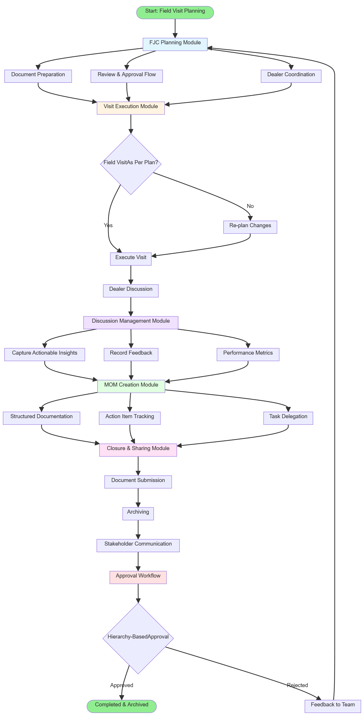
3. VE (Visit Execution Module)
This is where the actual field visit happens.
- Decision Point (Field Visit As Per Plan?)
  - If Yes → continue with visit execution.
  - If No → make adjustments or re-plan (route, schedule, etc.), then proceed.
- Execute Visit:
The field officer performs the visit as per the plan.
- Dealer Discussion:
The officer interacts with the dealer, discusses issues, collects insights, and notes feedback.
Then the process moves to Discussion Management (DM).

4. DM (Discussion Management Module)
Captures all outputs and insights from the field visit.
It involves:
- Capture Actionable Insights — key findings or improvement points.
- Record Feedback — inputs from the dealer or stakeholders.
- Performance Metrics — evaluate performance indicators or KPIs observed during the visit.
All this information flows into MOM (Minutes of Meeting) creation.

5. MOM (Minutes of Meeting Creation Module)
Organizes the discussion outcomes into a structured report.
- Structured Documentation: Create a clean summary of what was discussed.
- Action Item Tracking: Record who’s responsible for follow-ups.
- Task Delegation: Assign next steps to team members.
When done → move to Closure & Sharing.

6. CS (Closure & Sharing Module)
This phase finalizes the documentation and shares outcomes with relevant parties.
Steps:
- Document Submission: Submit the MOM and reports for review.
- Archiving: Save the finalized documents in the system.
- Stakeholder Communication: Share results and next steps with concerned teams or dealers.

7. AW (Approval Workflow)
Before closing the process, the system checks for hierarchy-based approval.
- If Approved:
→ The process ends successfully → Completed & Archived.
- If Rejected:
→ Feedback is sent back to the FJC Planning Module for correction or rework.

End: Completed & Archived
Once approved, the visit report and documentation are officially closed and archived for future reference.
3. Dealer Claim Process — Detailed Explanation (with Roles & Flow Context)
Start: Dealer Claim Process
- The workflow begins when an internal Requestor identifies a need for a dealer-related activity (like a promotional campaign, event, or service drive).
- The purpose here is to formalize the request and begin the structured claim cycle.

1. Request Initiation (Requestor — Marketing / Service / CNR)
- The Requestor initiates an Activity Request in the system.
- Information captured includes:
  - Activity Type: e.g., marketing event, service camp, or campaign.
  - Dealer Information: dealer code, name, region, etc.
  - Date/Location: when and where the activity will happen.
  - Activity Details & Period: description, duration, and objective.
- This forms the foundation for the dealer’s proposal submission.
Purpose: To officially define what activity is being requested and trigger the dealer’s response.

2. Proposal Submission (Dealer)
- Once the request is raised, the Dealer receives the request notification and prepares a proposal.
- The proposal includes:
  - Cost Breakup: estimated expenses for each activity component.
  - Timeline for Closure: planned start and completion dates.
  - Supporting Documents: like vendor quotes, plan layouts, or sample creatives.
- The dealer submits this proposal back through the system.
Purpose: To provide the company with transparent cost and execution details before approval.

3. Request Evaluation (Requestor)
- The Requestor reviews the dealer’s proposal in detail.
- At this stage, they can:
  - Approve / Confirm to Proceed — if the proposal meets expectations.
  - Request Clarification — if any details or documents are incomplete or unclear.
- The request may loop between the Requestor and Dealer until the proposal is satisfactory.
Purpose: To validate the dealer’s plan, ensuring feasibility, compliance, and accuracy.

4. Department Lead Approval (Dept. Lead)
- Once the Requestor confirms, the request moves to the Department Lead for supervisory approval.
- The lead reviews the confirmed proposal and decides whether to:
  - Approve the request, authorizing the next steps, or
  - Send it back for clarification, if additional information is required.
- Only approved requests proceed to budget allocation.
Purpose: To introduce a managerial control layer ensuring departmental oversight.

5. Budgeting (Finance / System)
- After the lead’s approval, the Finance/System automatically blocks the required budget under an Internal Order (IO) code.
- This ensures that sufficient funds are reserved for this activity.
- The IO acts as a financial tracking reference for that particular claim.
Purpose: To ensure financial readiness and prevent overspending before execution begins.

6. Activity Creation (System Automation)
- Once the budget is blocked, the system automatically creates an activity record.
- Simultaneously, auto-confirmation emails are sent to:
  - Requestor – confirming the creation and details.
  - Dealer – authorizing execution readiness.
  - Department Lead – for transparency and tracking.
- This automated communication keeps everyone aligned.
Purpose: To formalize the activity in the system and ensure all stakeholders are informed.

7. Activity Execution (Dealer)
- The Dealer executes the approved activity as per the defined plan and budget.
- After execution, the dealer uploads proof and completion documents, such as:
  - Invoices, bills, and expense details.
  - Photographs or reports of the completed event/activity.
  - Any mandatory compliance forms.
- These are submitted back to the Requestor for review.
Purpose: To confirm that the activity was completed as planned and provide documentation for claim validation.

8. Claim Approval (Requestor)
- The Requestor reviews the dealer’s submitted documents and validates them against:
  - Approved budgets and IOs.
  - Actual execution vs. planned activity.
  - Completeness of supporting proof.
- The Requestor may:
  - Approve fully,
  - Approve partially (if only part of the cost qualifies), or
  - Request additional information (if something is missing).
Purpose: To verify that the dealer’s claim is valid, properly executed, and financially accurate.

9. E-Invoicing (Finance / System)
- Once the claim is approved, the Finance or System module generates:
  - An E-Invoice for the claim settlement.
  - A Credit Note, if necessary, to adjust differences or partial approvals.
- These financial documents complete the reimbursement cycle and allow payment to be processed.
Purpose: To close the financial loop by issuing official documents for claim payment.
End: Claim Settled
- The dealer’s claim is now officially settled.
- The system logs all actions for auditability and record-keeping.
- Both internal teams and dealers can access the status or reports for transparency.
Purpose: To ensure a fully documented, traceable, and compliant closure of the claim process.
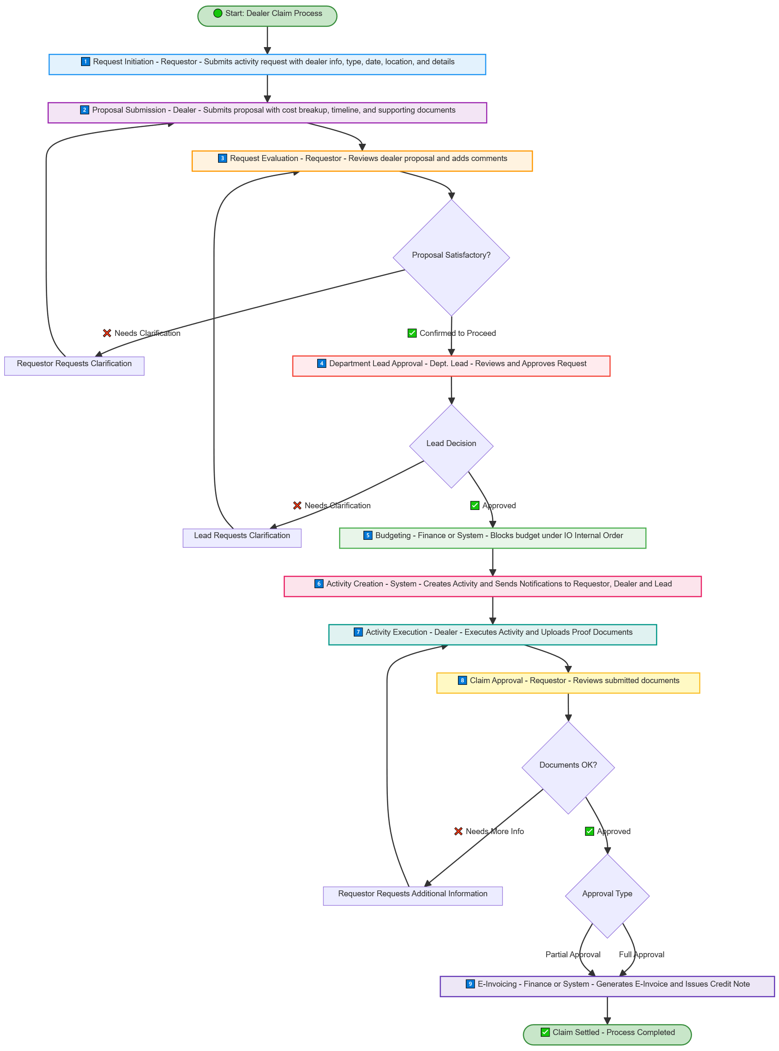
4. Dealers Approval Hierarchy
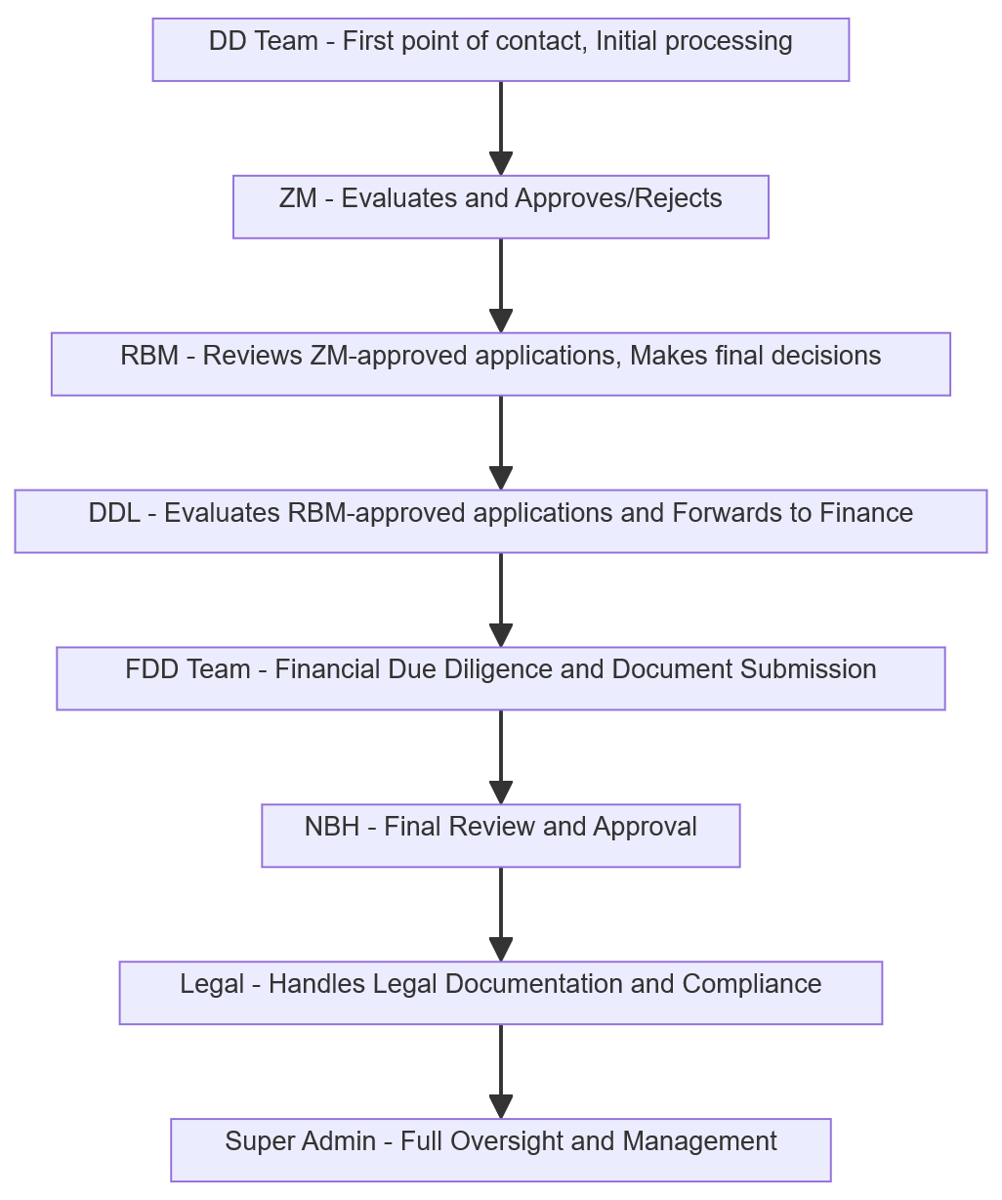
1. DD Team – First Point of Contact
- The DD Team receives the new application first.
- They do initial verification, check completeness, and ensure all required documents are submitted.
- Once the basic checks are done, the application moves to the ZM.

2. ZM – Zonal Manager
- The ZM (Zonal Manager) reviews the application in detail.
- They decide whether it should be approved or rejected at their level.
- Approved applications move up to the RBM for further review.

3. RBM – Regional Business Manager
- The RBM double-checks applications approved by the ZM.
- This is a regional-level review — ensuring accuracy, compliance, and business justification.
- After making a final decision, approved cases move to DDL for processing toward finance.

4. DDL – Due Diligence Lead
- The DDL reviews all RBM-approved applications again to ensure due diligence is complete.
- Once satisfied, the DDL forwards these applications to the FDD Team (Finance Due Diligence).

5. FDD Team – Financial Due Diligence
- The FDD Team performs financial verification and document validation.
- They ensure all financial records, proofs, and compliance details are correct.
- When ready, the application goes to the NBH for final review.

6. NBH – National Business Head
- The NBH conducts the final business review.
- They either approve the application for final processing or send it back for clarification.
- Approved applications then move to the Legal team.

7. Legal – Documentation & Compliance
- The Legal department prepares contracts, agreements, and ensures compliance with regulatory standards.
- Once all legal paperwork is completed, the application moves to Super Admin for overall management visibility.

