User Guide

Steps to Create a Custom Workflow
- Access the workflow through the provided link: “https://drawer-revel-35038897.figma.site/”.
- Click on the Admin Login button.
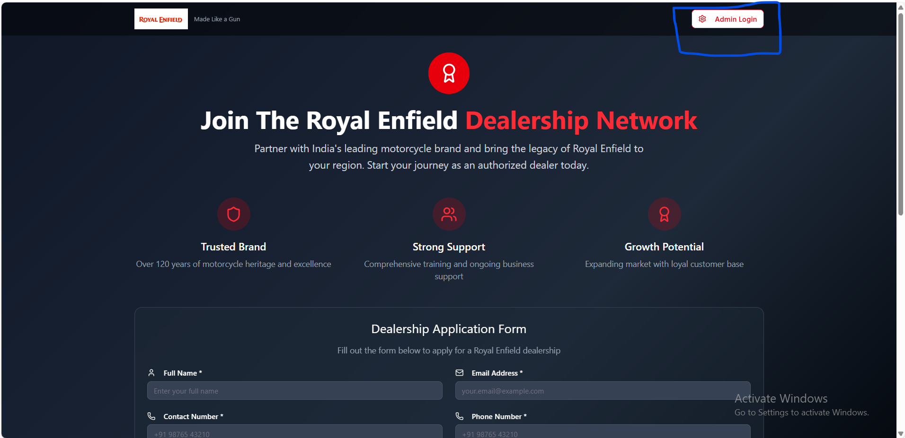
- From the dropdown menu, select the Super Admin role and click on Sign In.
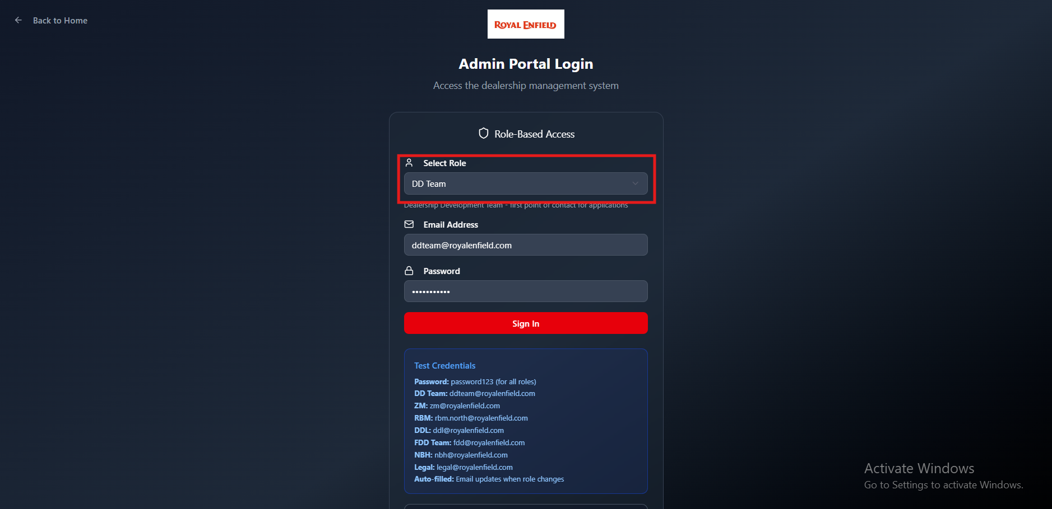
- On the dashboard, click on Create Custom Workflow.
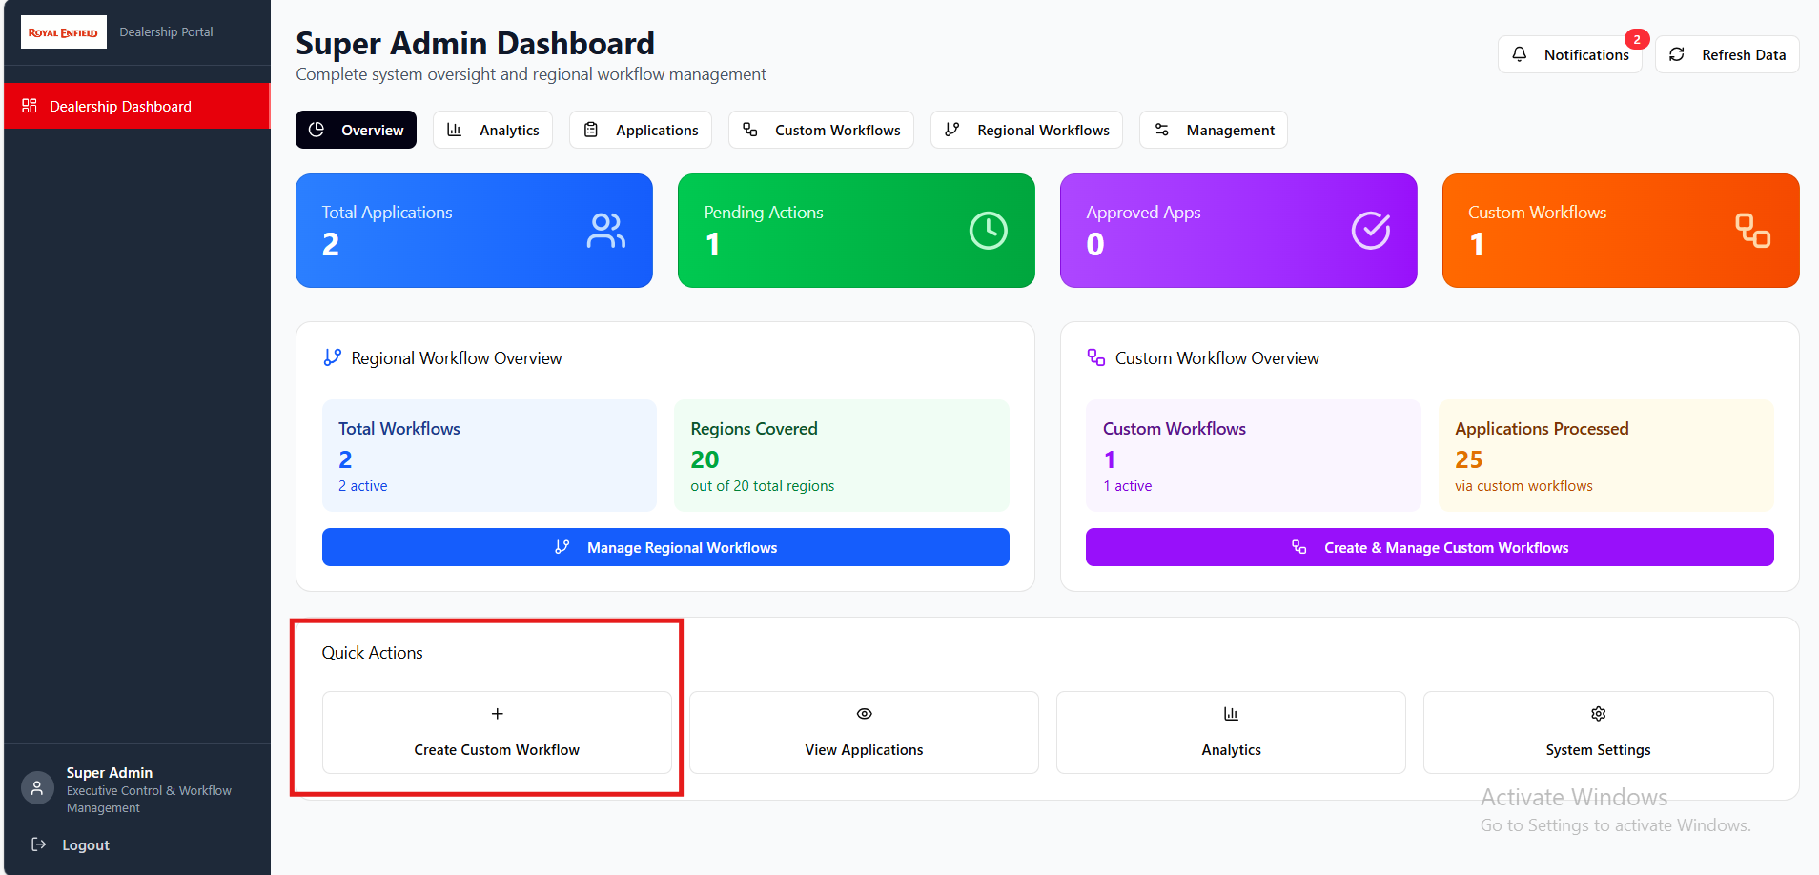
- Select the Create Custom Workflow button.
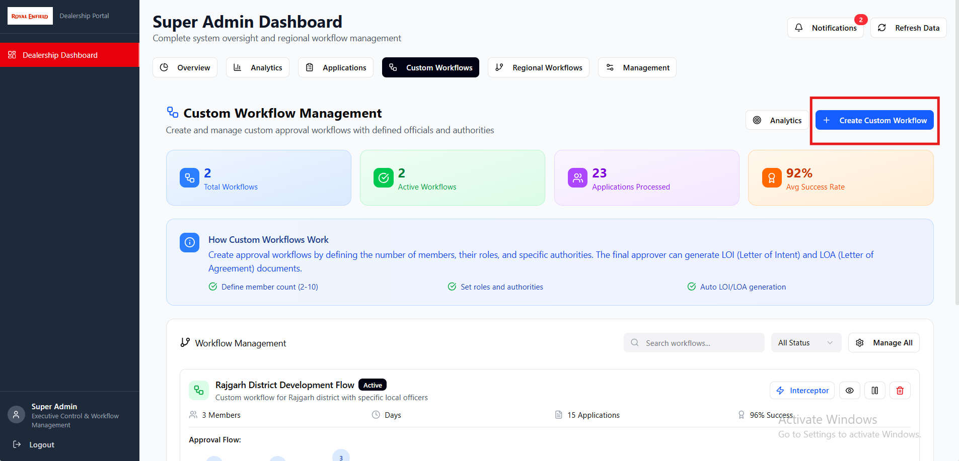
- You will be presented with two options:
  - Use Template – to proceed with an existing workflow template.
  - Start from Scratch – to design a new workflow as per your requirements.
After selecting the preferred option, click Next.
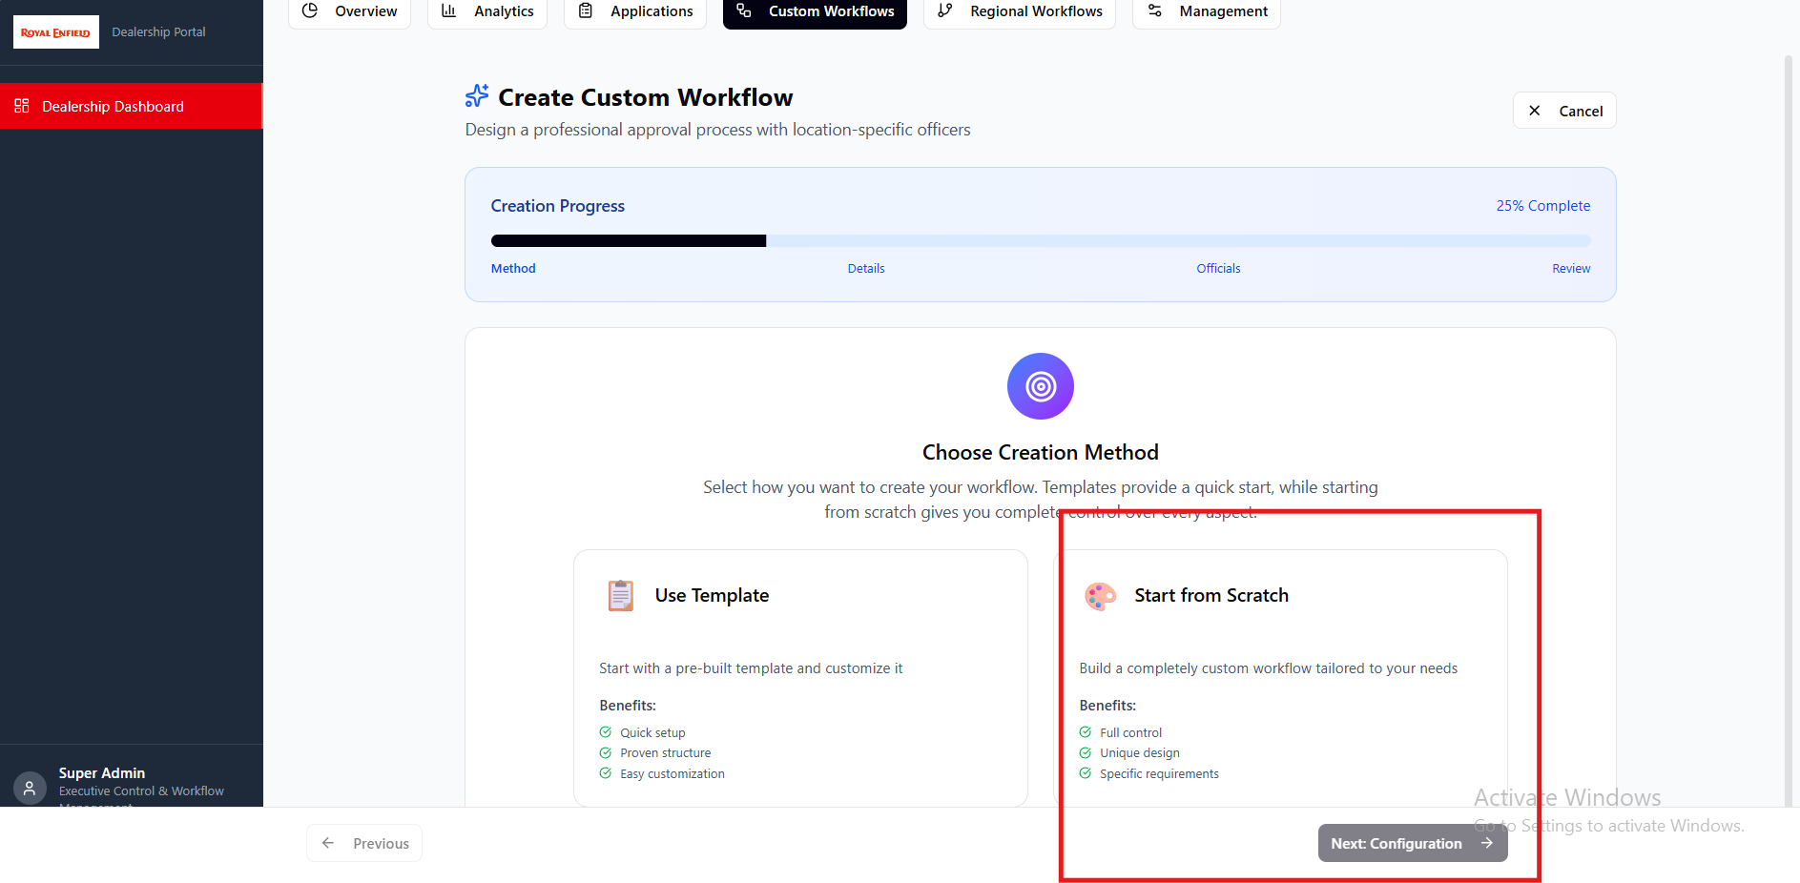
- Provide the following details:
  - Workflow Name
  - Number of Users involved (select from the dropdown)
  - Description (optional)
  - Advanced Options (optional)
Once entered, click Next.
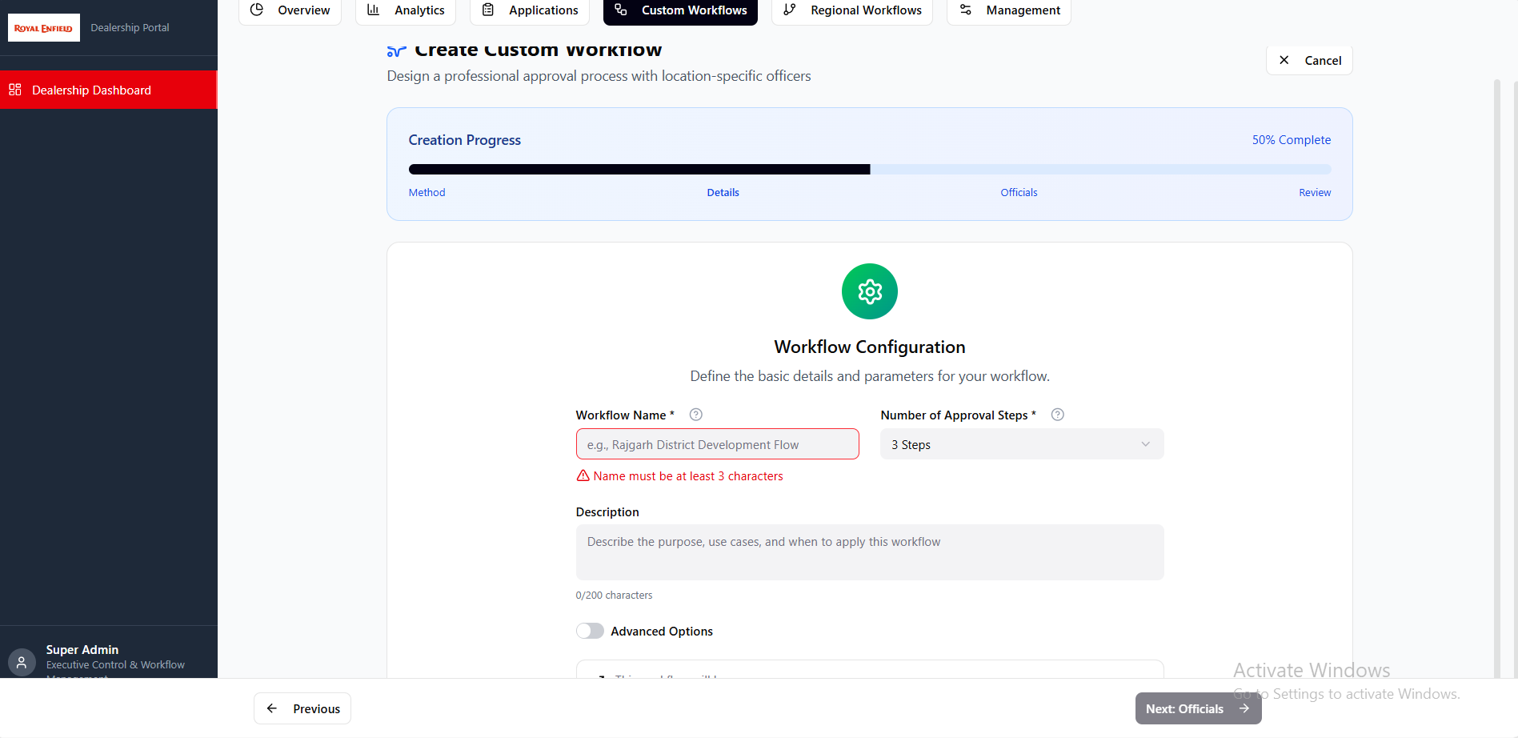
- Based on the number of users selected, you will see individual cards (one card per user). For example, if three users are selected, three user cards will appear.
  - Assign the Role and Department to each user.
  - For predefined roles (DD, RBM, NBH, Finance), demo data will automatically fetch user details.
  - For new users, use the Custom Officer fields and Officer Email field to define user information.
  - In the Authorities and Permissions section, assign specific rights and permissions to each user.
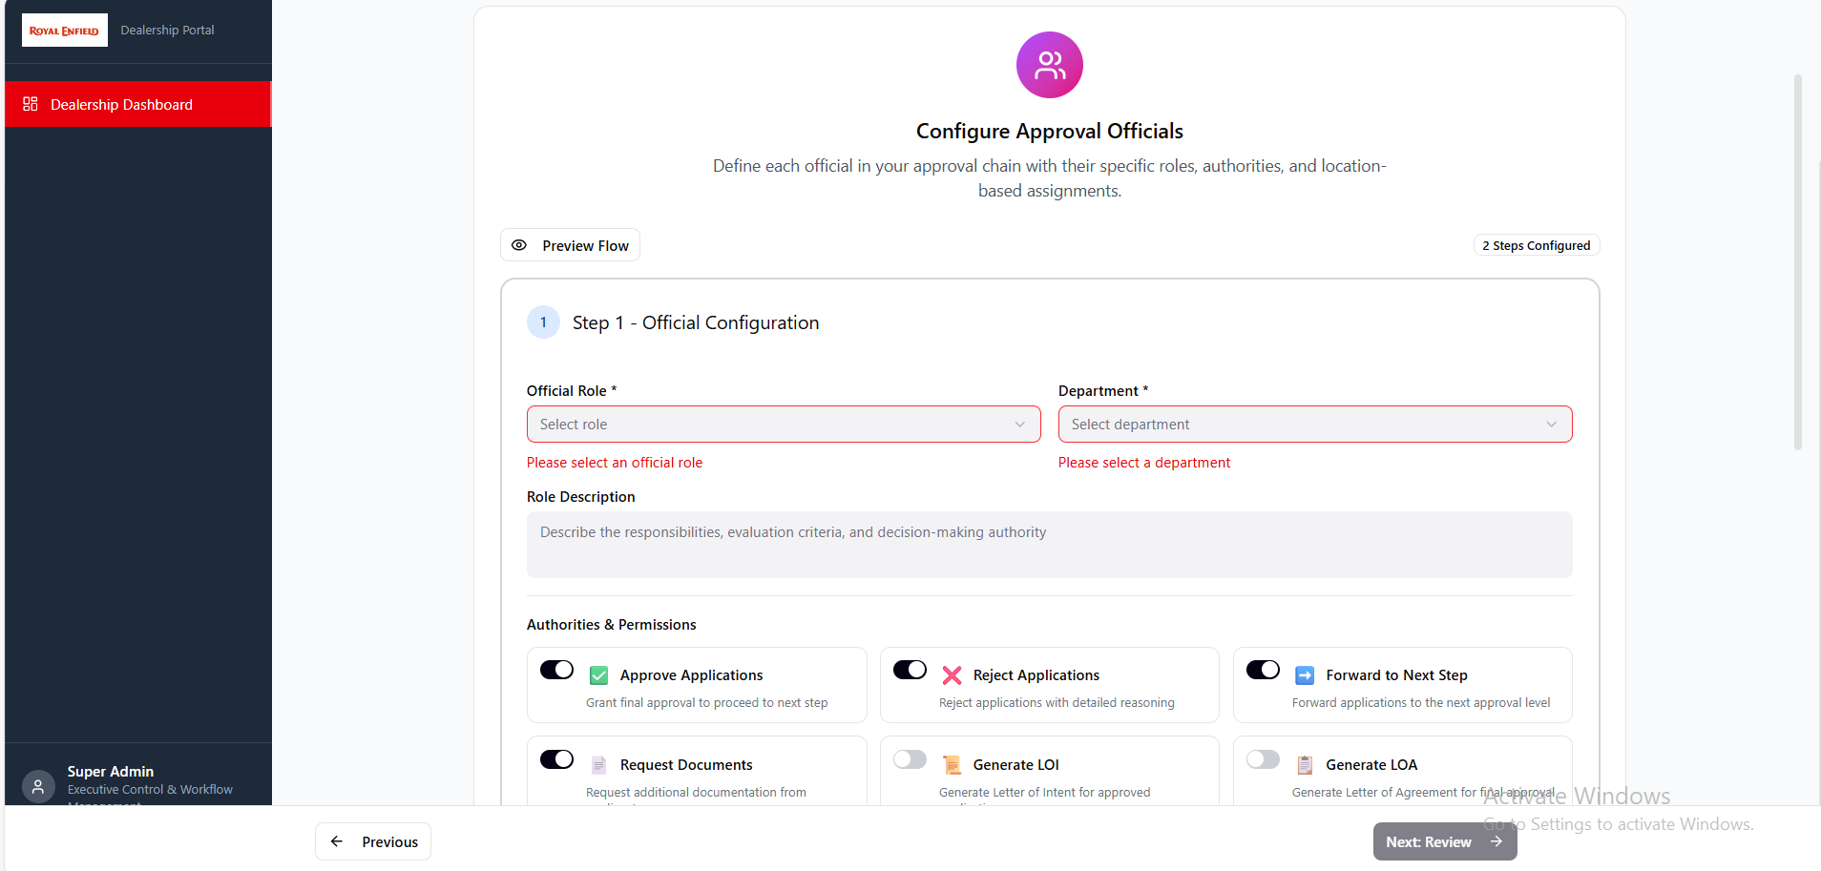
- Repeat the process to fill in the details for all other users.
- By default, LOI and LOA generation permissions are assigned to the final user.
- After entering all required details, click Next.
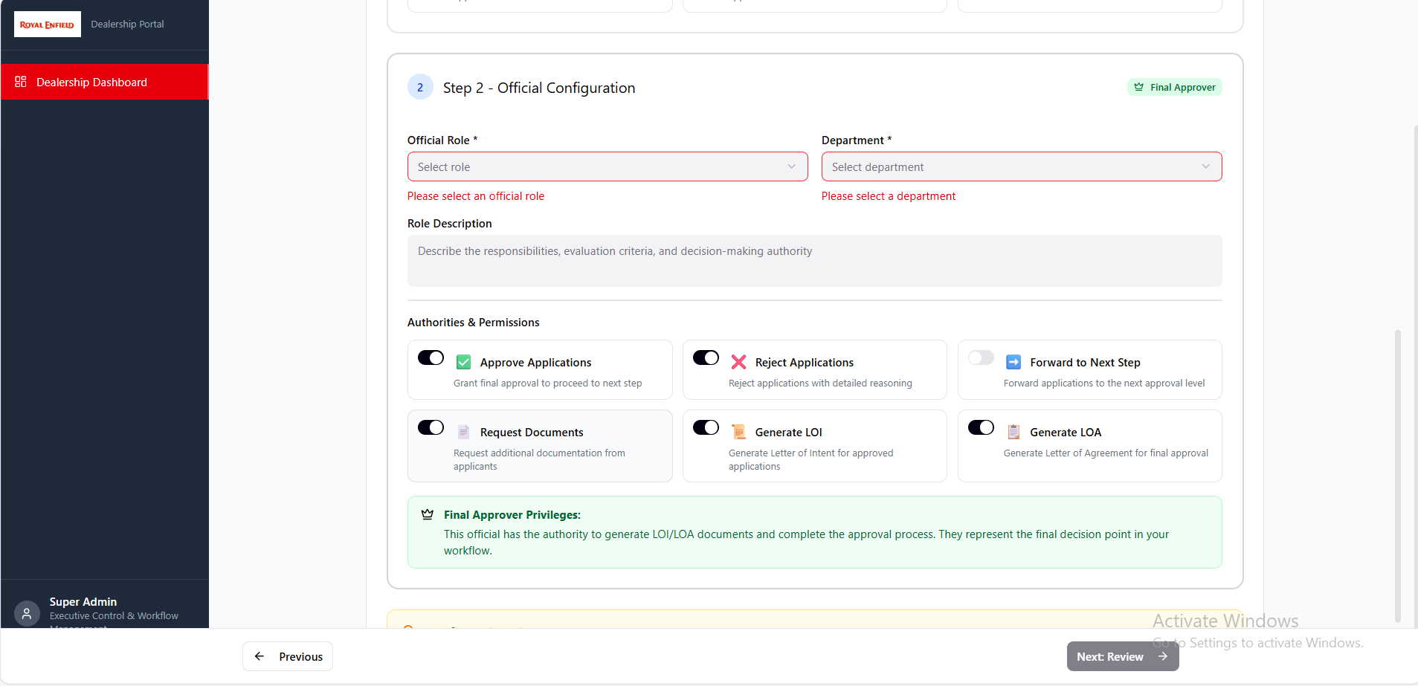
- Review the workflow details carefully and click on Create Workflow.
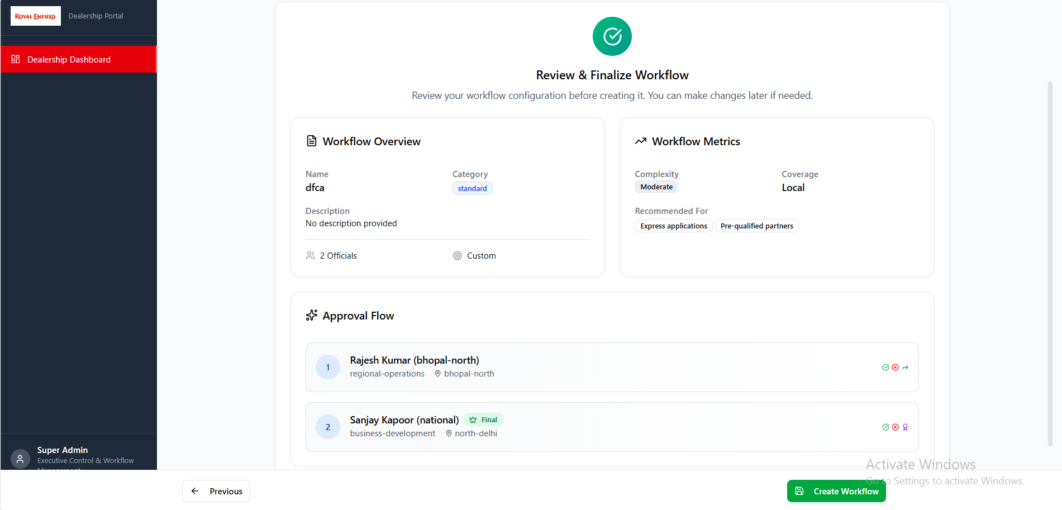
- Your workflow is now successfully created.
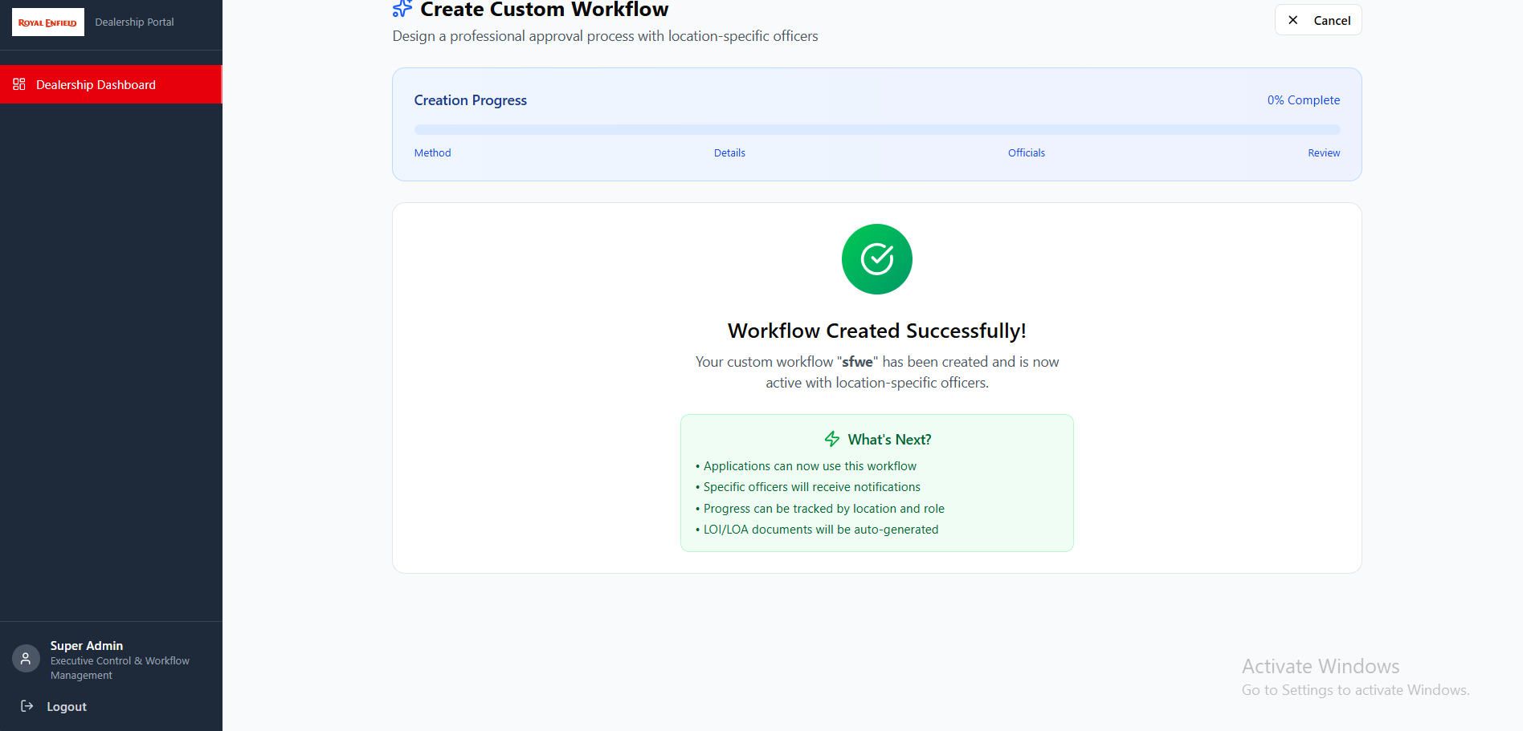

- The newly created workflow will be displayed on the current screen.

